NAME: VENKATRAMAMOORTHY.G
Question 1:
CODE:
<body>
<div class="container">
<div class="row">
<div class="col-lg-4 border bg-primary">column 1</div>
<div class="col-lg-4 border bg-success">column 2</div>
<div class="col-lg-4 border bg-warning">column 2</div>
</div>
</div>
</body>
OUTPUT:
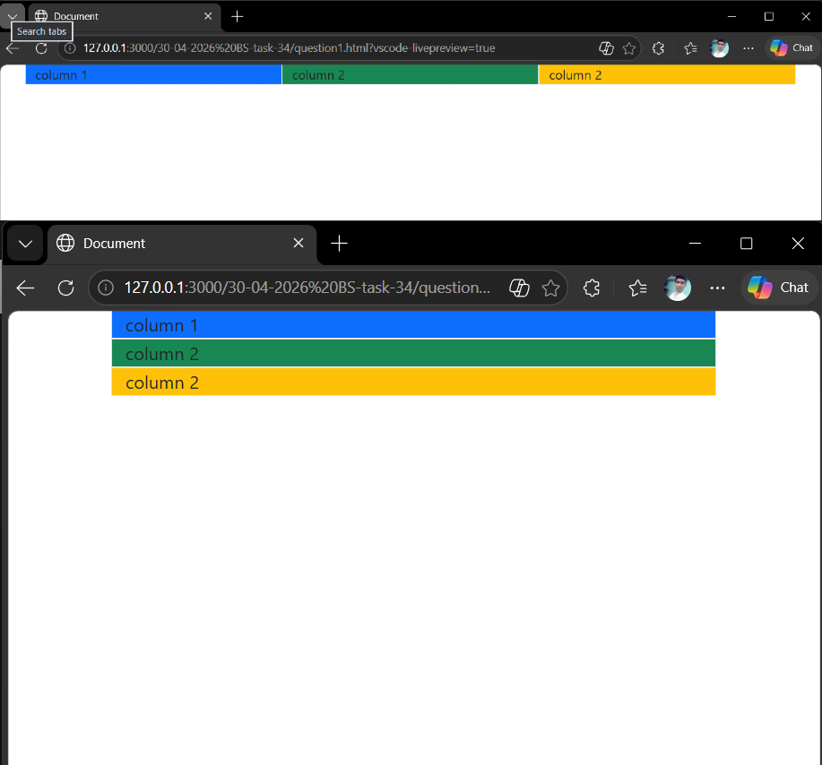

Question 2:
CODE:
<body>
<div class="container">
<div class="row">
<div class="col-6 border bg-primary">
<div class="row">
<div class="col-6 bg-danger">sub coloum 1</div>
<div class="col-6 bg-warning">sub coloum 1</div>
</div>
</div>
<div class="col-6 border bg-success">column 2</div>
</div>
</div>
</body>
OUTPUT:
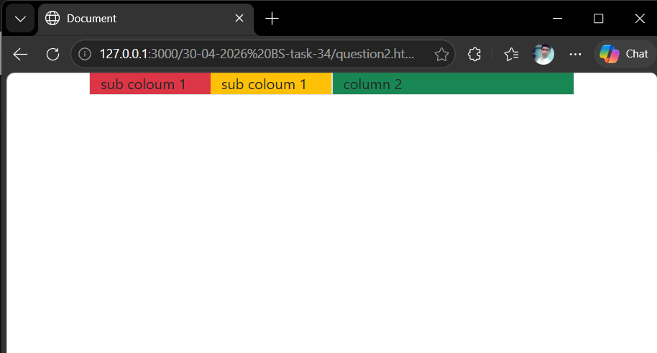

Question 3:
CODE:
<body>
<nav class="navbar navbar-expand-sm p-3 bg-danger ">
<ul class="navbar-nav">
<li class="nav-item"><a class="nav-link" href="#">Home</a></li>
<li class="nav-item"><a class="nav-link" href="#">About</a></li>
<li class="nav-item"><a class="nav-link" href="#">Contact</a></li>
</ul>
</nav>
</body>
OUTPUT:
